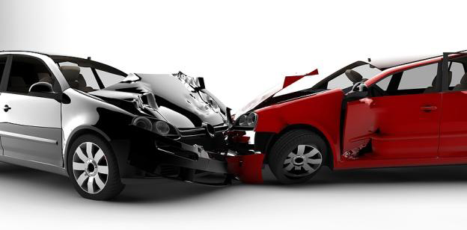

**Factors Affecting Major Injuries**

Business Intelligence Tools and Technologies - MSIS 5633

Group - 3

Chakradhar Pathi - A20096739

Mrunali Kadam - A20114076

Ravali Musty - A20101635

**Executive Summary**

National Highway Transportation Safety Administration (NHTSA) is a branch of department of transportation in the United States. Its’ mission is “Save lives, prevent injuries, reduce vehicle-related crashes.” The purpose of our study is to help to contribute to the mission. Source of the data is a National Automotive Sampling System (NASS) General Estimates System (GES).

The purpose of this project is to identify the factors affecting the major injury severity. In this project, we will build models like Random Forests, Decision Tree, and Neural Network to predict the outcome of major injury severity. We will use KNIME software for model building. This will help us to identify the severity of accident whether it was a major or minor. Then we will evaluate the correctness of the model and draw insights. Also, this study will help us to provide safety recommendations in order to avoid accidents.

**Business Understanding**

The National Highway Transportation Safety Administration (NHTSA) has collected data related to all types of car crashes. In the United States, on average, there are around 5 million car crashes happen annually and thousands of crashes occur every year. Around 32,000 deaths happened in the motor vehicle accidents alone in 2014. Also, there is a huge loss of human lives, property whenever such accidents happen. Many people are imputed, and property damage occurs. The total cost of societal harm from motor vehicle crashes in the United States was approximately $836 billion in 2010. Over 90% of Americans owned at least one vehicle in 2009. So, this study and outcomes would really help everyone and help to understand the significant factors of crashes. We will use this data to build our prediction models.

**Data Understanding**

The car accident data contains 4 data files named accident, person, vehicle and distract. Data files are in .sas7 format. Accident data file contains information about crash and environmental conditions at the time of crash. Person data file contains the information about all persons involved in the crash. Vehicle data file contains the information about in-transport vehicles. Distract data file contains the details about driver distraction. We got total 195 variables and 135900 records after merging all the four data files. However, we require specific variables for our analysis. We manually verified all the variables to understand the importance of which variable would help us in analysis. Along with that we used forward feature selection method to identify the top 20 variables associated to the injury severity. The variables which we have finalized for our analysis are:

ACCIDENT:

ALCHL_IM - This variable records the alcohol use for drivers, pedestrians and other types of non-motorists involved in the crash

DAY_WEEK - This variable identifies the day of week crash occurred

HOUR - This variable records the hour at which crash occurred

LGT_COND - This variable records the type of light that existed at the time of crash

MAN_COLL - This data element describes the orientation of two motor vehicles in-transport when they are involved in the collision crash

MONTH - This data element records the month in which the crash occurred

PERNOTMVIT - This data element records the number of non-motorists in the crash

REL_ROAD – This variable identifies the location of the crash as it relates to its position within or outside the trafficway.

TYP_INT - This variable identifies and allows separation of various intersection types

WRK_ZONE - This variable identifies the traffic crash in which the first harmful event occurs within the boundaries of a work zone

REGION - This variable records the region of the country where crash occurred

WEATHER- This variable records the atmospheric conditions that existed at the time of crash

PERSON:

AGE - This variable identifies the age of person involved in the crash

AIR_BAG - This variable identifies the airbag availability and deployment for this person

INJ_SEV - This variable identifies the severity of the injury to this person in the crash

SEX_IM - This variable identifies the sex of person involved in the crash

SEAT_POS - This variable identifies the location of person in or on the vehicle

VEHICLE:

MAX_SEV: This variable identifies maximum injury severity of all persons involved in crash.

NUMOCCS: This variable is a count of the number of occupants in the vehicle.

ROLLOVER: This variable records vehicle’s involvement in a rollover or overturn during crash.

VSURCOND: This variable identifies the attribute that represents the roadway surface condition prior to the crash.

BODY_TYP: This variable identifies a classification of this vehicle based on its general body configuration, size, shape, color etc.

TRAV_SP: This variable identifies the speed the vehicle was traveling prior to the crash.

DEFORMED: This variable identifies the amount of damage that is the severity of damage.

HIT_RUN: This variable identifies the attribute that represents whether the driver of a vehicle involved in a crash stop or run away.

DISTRACTION:

We did not use any variables in distraction data file. Because this data is not much related to our analysis and would not help us in the prediction of our business questions.

**Data Preparation**

Four different input files were used for this analysis that is vehicle, person, accident, distract. Files were in SAS7 format, so we used SAS7BDAT reader node to read all the input files. Joiner node is used to join all the data files.

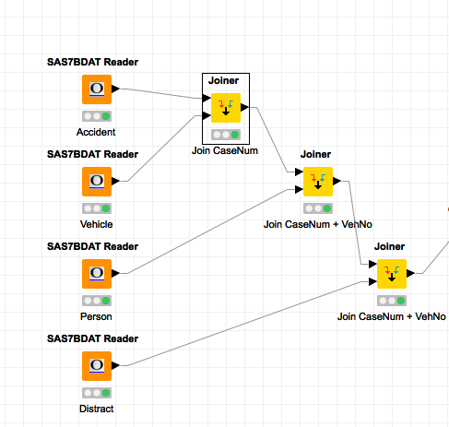

We have joined the data on Case Number and Vehicle number. After joining all the files, we got a total of 195 columns.

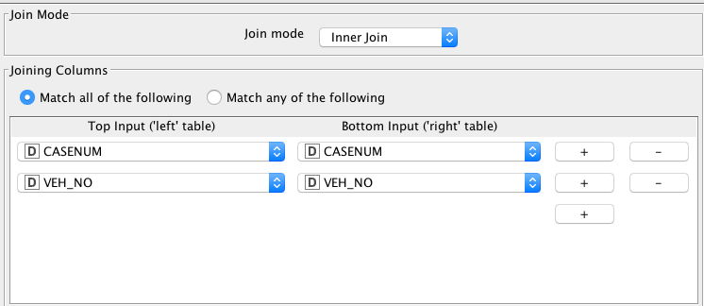

Then we applied column filter to select the final columns. Many columns are repetitive and contains same information. So, we have carefully selected our columns which would help us in the analysis. Final column count is 27.

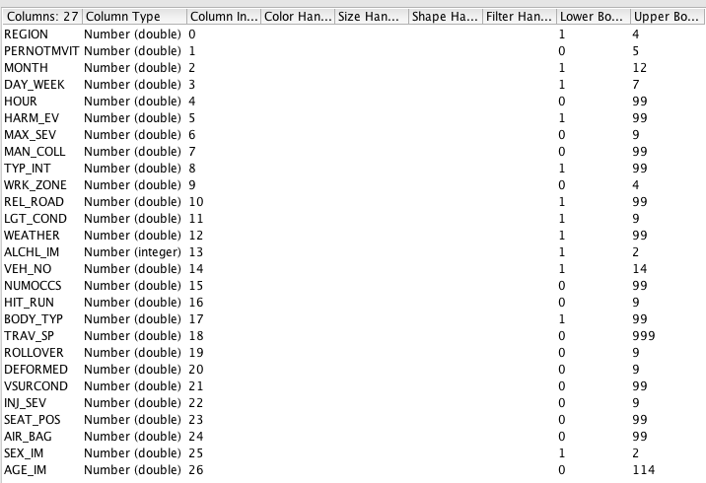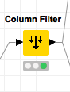

We also verified descriptive statistics results for both categorical and numerical variables. This helped us to understand the distribution all categories and which variable needs to be binned.



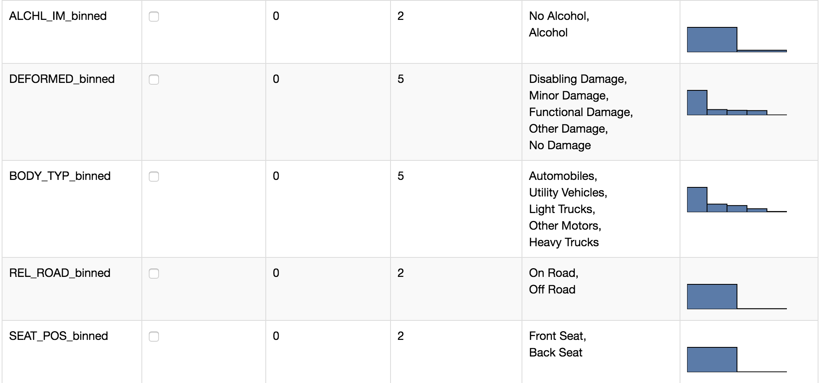



Rule-based filter is applied on data to remove erroneous values such as traveling speed greater than 997, and numer of occupants greater than 97. We did not remove missing values and handled them for categorical columns.

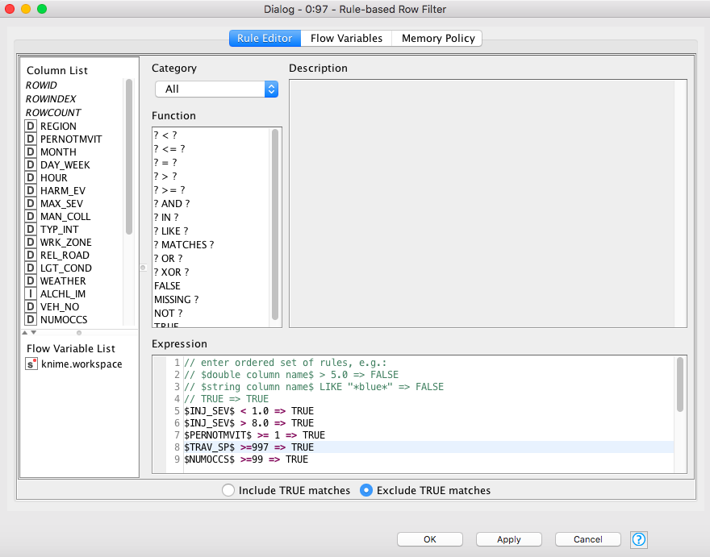

We used numeric binner to bin many columns in order to reduce the number of possible values and put them in a specific interval. Type of intersection column was divided into 10 categories initially. So, we binned data into 4 categories only as shown below.

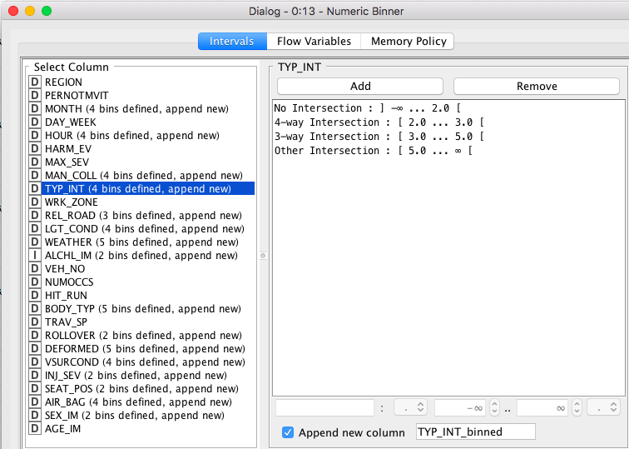

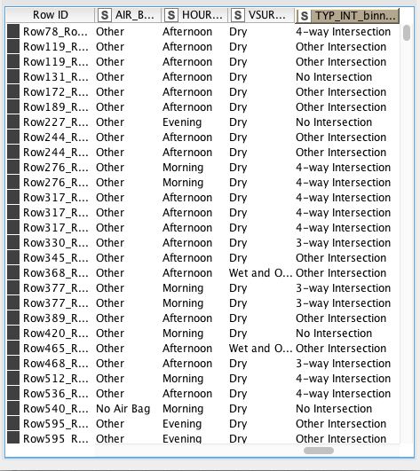

Then we again applied column filter to select final binned columns and other required columns. So, the final column count is 21 now.

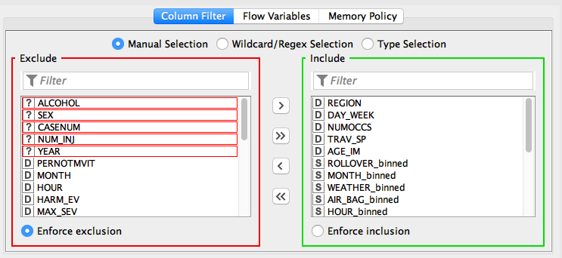

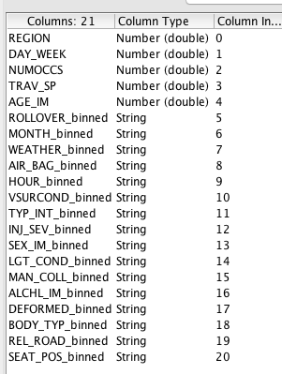

We have also used Number to string node to convert columns of number format to string format, one to many nodes to create dummy variables. Normalizer node is used for normalization of dummy variables and the other numerical columns. We can transfer this data to Neural Network model.

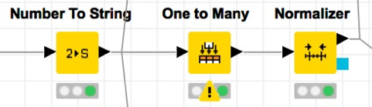

Also, we used linear correlation node to identify the correlation among the all variables.

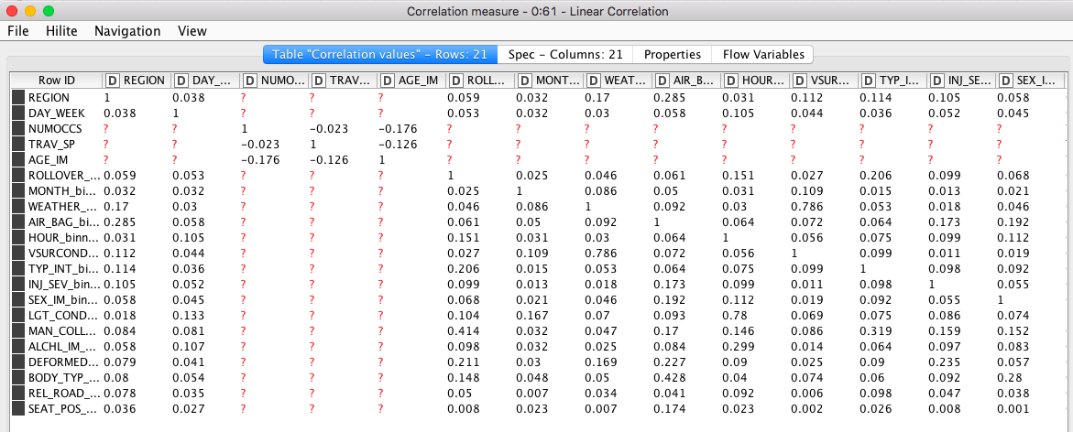

We now partition the data into Training Data and Testing Data as our next step. Training data is used to build a model and Testing data is used to check the correctness of the model. We can use Partitioning node to split the data into Training Data and Testing Data.

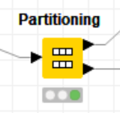

The number of records in the training and test data were 12782 and 5478 respectively after splitting the data in 70% and 30% respectively. The configuration for the Partitioning node is shown below.

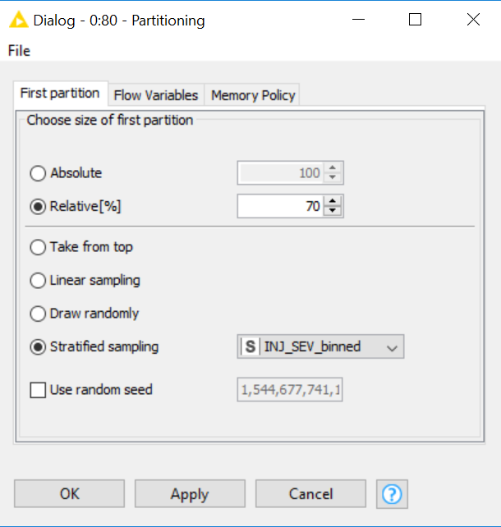

The distribution of our target variable “INJ_SEV_BINNED” is shown below. Clearly, the ‘Minor’ injuries class is about 4 times bigger than the ‘Major’ injuries class.

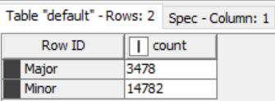

It is important that we balance the training data set so that the learning nodes can accurately analyze the minority class, which in this case is the ‘Major’ injuries. The ‘Smote’ and “Equal Size Sampling” node can do this by simulating and adding required new data to the ‘Major’ class that is almost similar and equal in size. We would be evaluating the models and their assessments with both unbalanced and balanced dataset using the Sampling techniques discussed above. Hence, the steps to the data preparation are now finished.

**Model Building**

The three models we used for predicting the target variable were:

1. Artificial Neural Networks

2. Decision Tree

2. Random Forest

**Artificial Neural Networks:**

Artificial Neural Networks is simply an interconnected group of nodes quite like neurons in a brain. They are brain-inspired systems which are intended to replicate the way humans learn. The RProp MLP Learner is used to build the model, and the training data is provided as input to the RProp MLP Learner. Multilayer Perceptron Predictor is used to test the correctness of the model. Testing dataset and the model from Learner are provided as input to the Multilayer Perceptron Predictor.

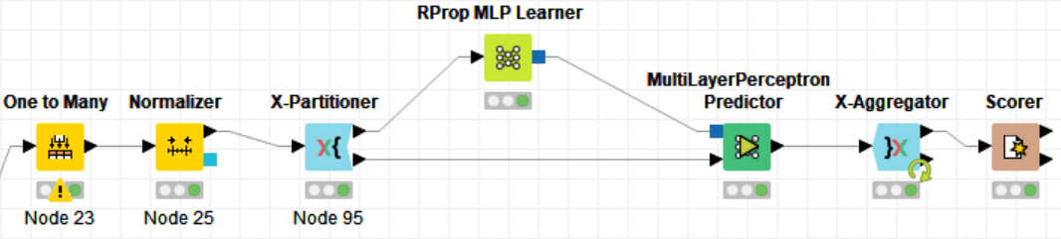

We applied cross-validation technique with 10 folds for this ANN model. The configuration is shown below:

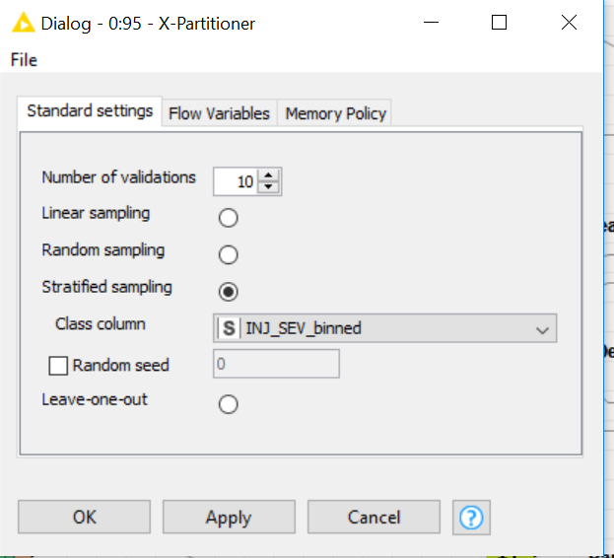

The configurations of RProp MLP Learner shown in the figure below:

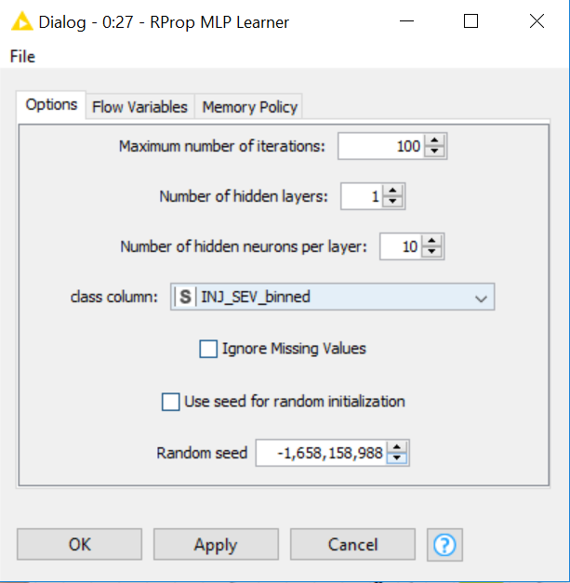

The configurations of Multilayer Perceptron Predictor are shown in the figure below:

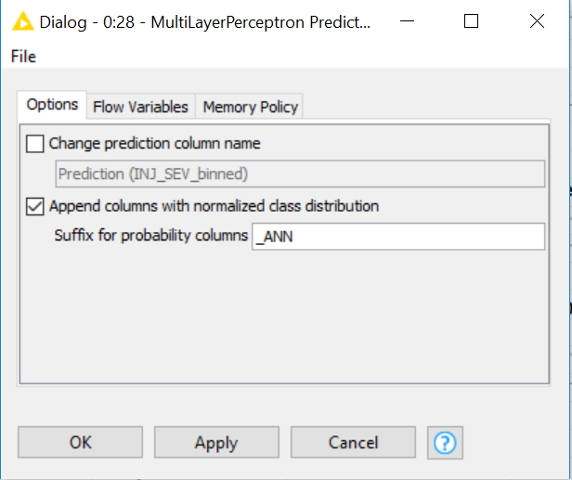

Finally, the X-Aggregator node aggregates all the 10 folds and gives the results, the configuration for this node is shown below:

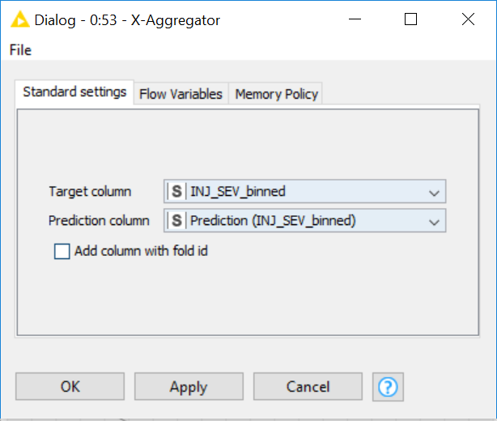

**Decision Tree:**

Decision trees are tree-like models that creates a flow of if-then statements by splitting the data set into categories based on the values of the variables. This process is repeated over and over until the final decision tree model is complete. The Decision Tree Learner is used to build the model, and the training data is provided as input to the Decision Tree Learner. Decision Tree Predictor is used to test the correctness of the model. Testing dataset and the model from Learner are provided as input to the Decision Tree Predictor.

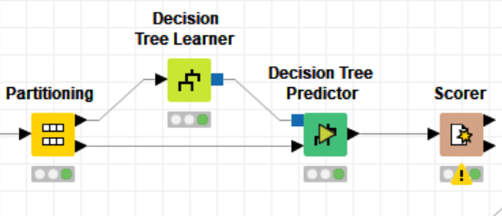

The configurations of Decision Tree Learner shown in the figure below:

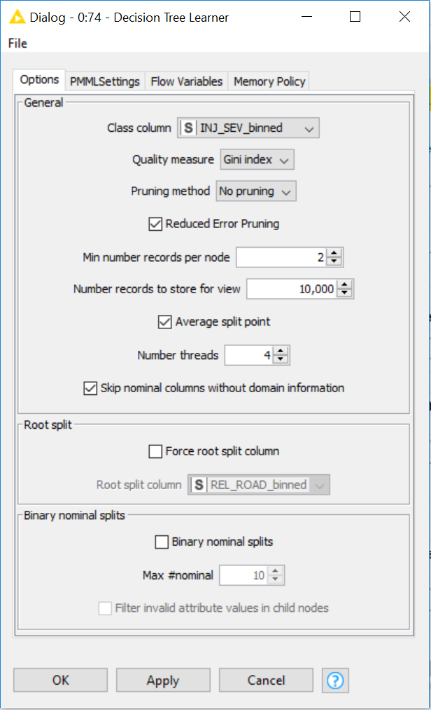

The Decision tree view from the learner is shown in the figure below:

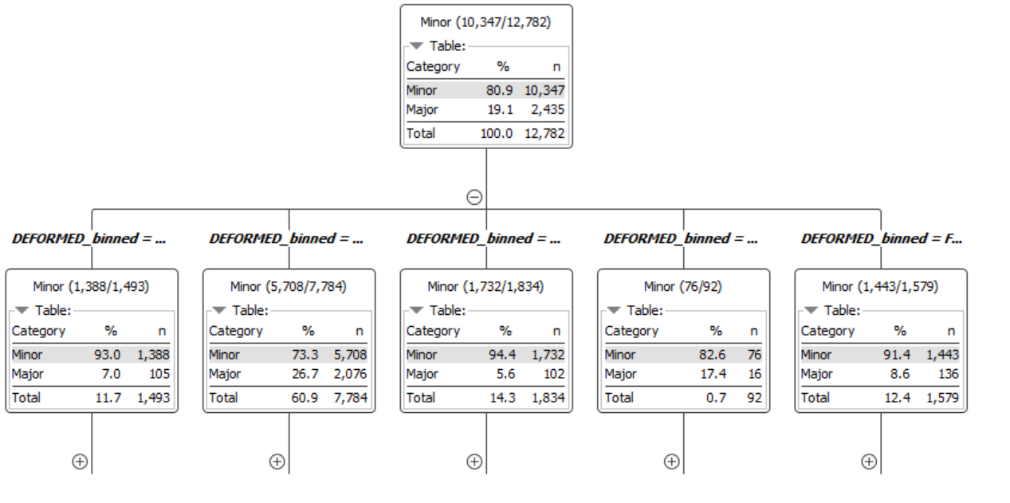

The configuration for Decision Tree Predictor is show in the figure below:

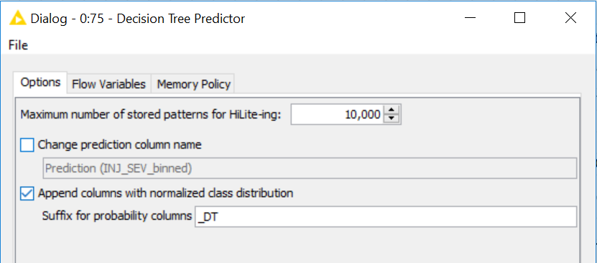

**Random Forest:**

Random forests are like decision trees, in this, a “Forest” of many small decision trees are developed. The most useful aspect of Random Forests is that they weight each of the variables based on the prediction outcomes. We can also see which variables are the most useful for predicting the ‘Major’ injuries. The Random Forest Learner node is used to build the model from training data set and Random Forest Predictor is used to test the model using Testing dataset.

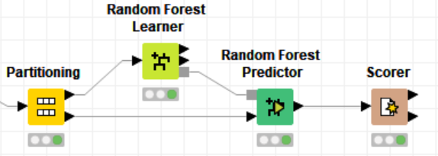

The configuration for Random Tree Learner is given below. The “Information Gain Ratio” was used as the Split Criteria and 100 was the number of trees in the model used.

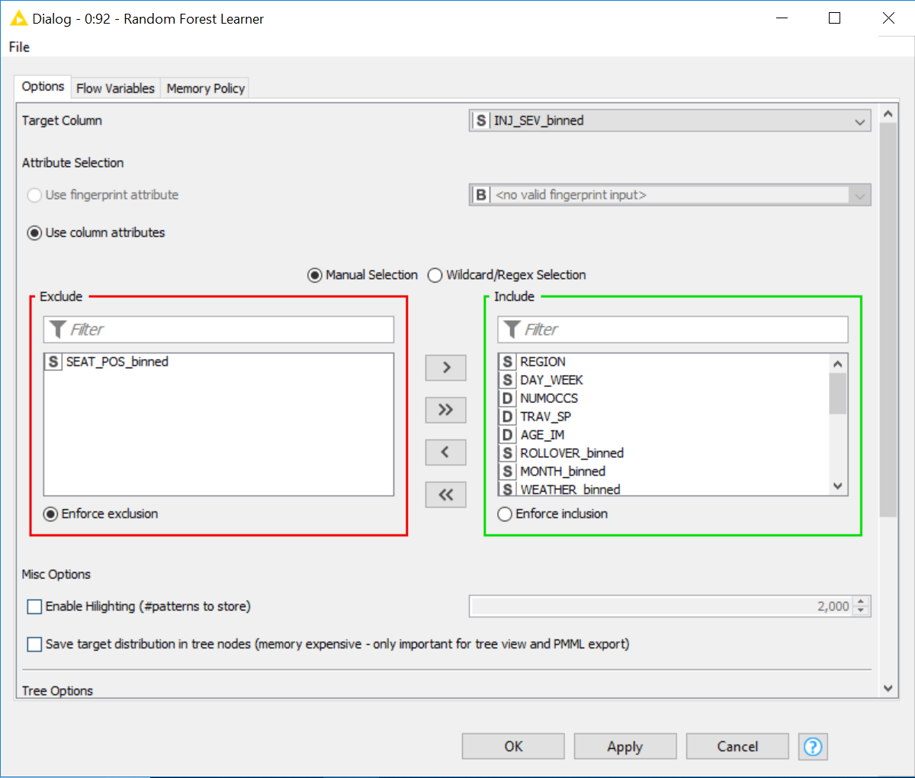

The Random Forest tree view after the Learner is shown in the figure below. Only one tree view out of 100 trees of a Random Forest is shown below as an example.

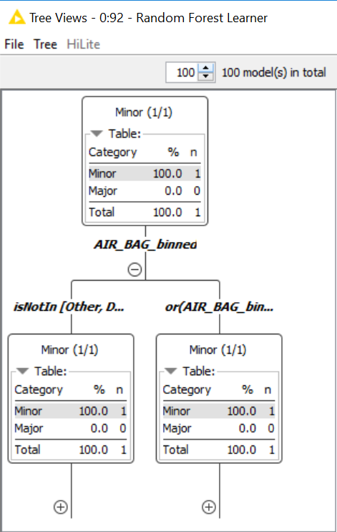

The configuration for Random Forest Predictor is shown below:

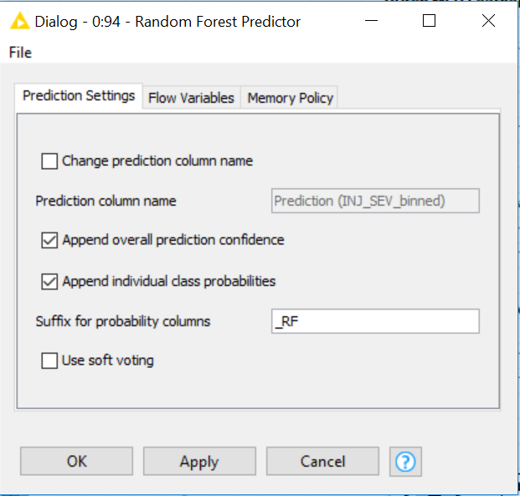

**Model Evaluation**

*Testing and Evaluation with Unbalanced class*

**Artificial Neural Networks:**

The output of MLP Predictor is given to a Scorer Node. It calculates the Accuracy Percentage and generates Confusion Matrix that shows the Sensitivity and Specificity along with the number of True Positives, True Negatives, False Positives, and False Negatives. The Accuracy Statistics of ANN is shown in the following figure:

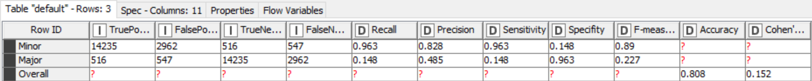

The Confusion Matrix of ANN is shown in the following figure:

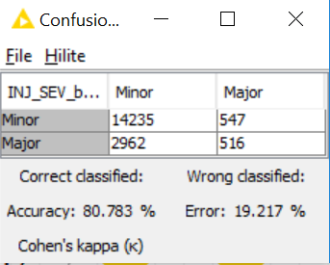

Hence, we can see the ANN model accuracy is 80.783%.

**Decision Tree:**

The output of Decision Tree Predictor is given to a Scorer Node. It calculates the Accuracy Percentage and generates Confusion Matrix that shows that shows the Sensitivity and Specificity along with the number of True Positives, True Negatives, False Positives, and False Negatives. The Accuracy Statistics of Decision Tree is shown in the following figure:

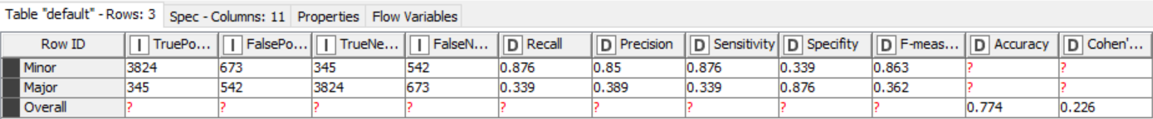

The Confusion Matrix of Decision Tree is shown in the following figure:

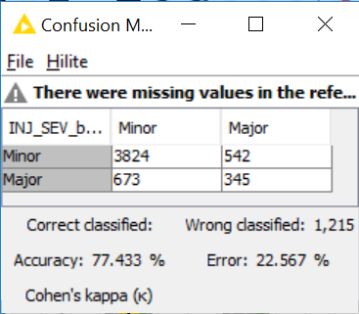

Hence, we can see the Decision Tree model accuracy is 77.43%.

**Random Forest:**

The output of the Random Tree Predictor Node is given to scorer as an input which calculates Confusion Matrix and predicts Accuracy Percentage. Accuracy Statistics is shown below:

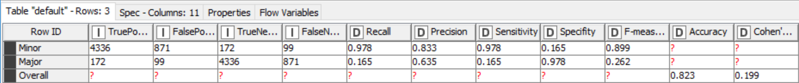

The Random Forest Confusion Matrix is shown below:

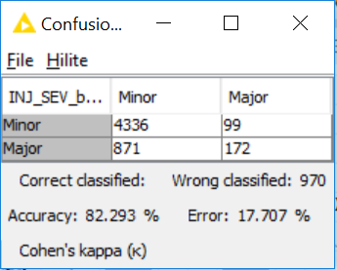

The Accuracy Percentage for Random Forest is 82.293 % as seen from Accuracy Statistics table.

Using the ROC curves that shows a plot between true positive rate (TPR) and false positive rate (FPR) at various threshold settings we observe the ANN and Random Forest models performed decently well and Decision Tree model is the least performer.

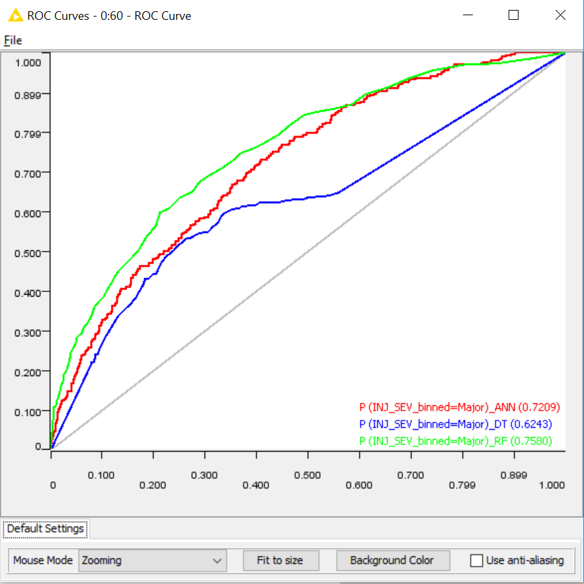

*Testing and Evaluation with Balanced class:*  
In all our models the obtained sensitivity values were low, this could be due to the unbalanced class of our target variable. Hence, we tried to balance the training dataset by “Equal Size Sampling” dataset to improve the model sensitivity. This node gave us better results than the ‘Smote’ node after several trial and error methods. The configuration for all the “Equal Size Sampling” nodes is shown below in the first screenshot.

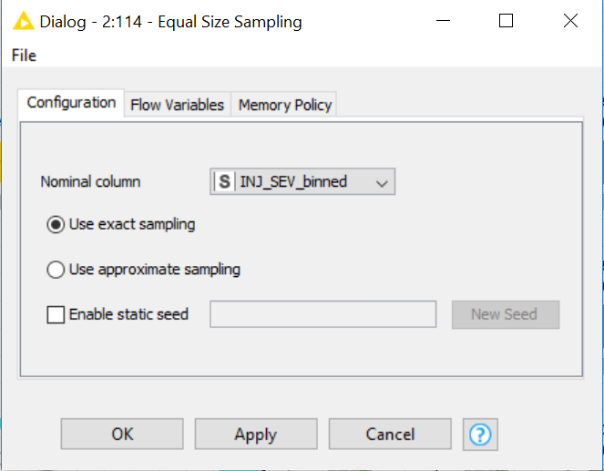

The three models that used the sampling technique is shown in the screenshot below.

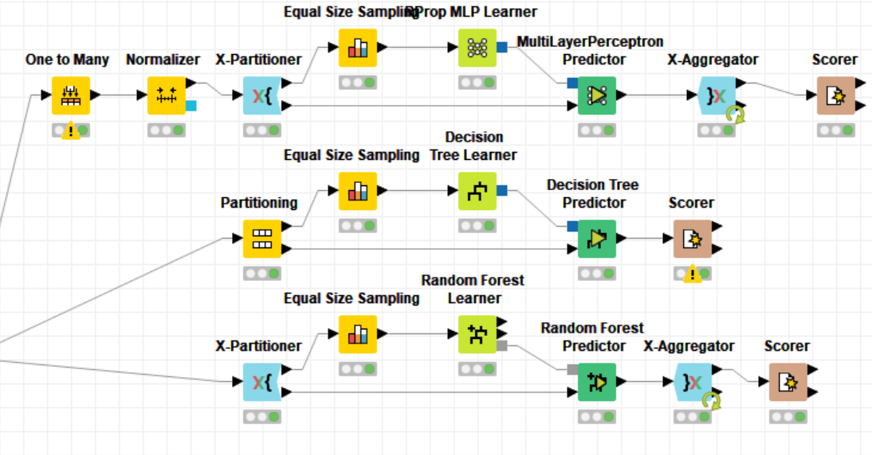

Upon using the above sampling technique, we obtained new results that improved the sensitivity of predicting the “Major” injury class. The results for each of the models are shown below:

**Artificial Neural Networks:**

The ANN model gives an improved sensitivity of 70% and a specificity of 64%. We observe the accuracy fell to 65.1%. The details are shown in the two screenshots below. The details are shown in the two screenshots of accuracy statistics and confusion matrix below.

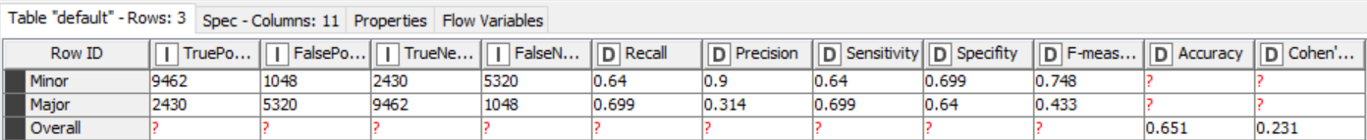

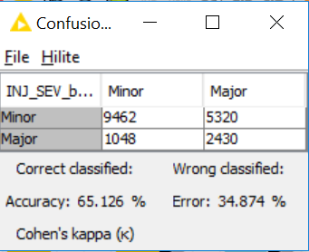

**Decision Tree:**

The Decision Tree model gives an improved sensitivity of 62.2% and a specificity of 64.6%. We observe the accuracy fell to 64.2%. The details are shown in the two screenshots of accuracy statistics and confusion matrix below.



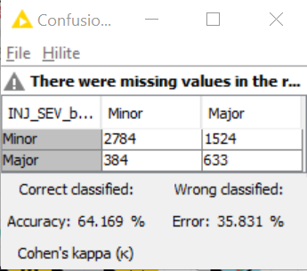

**Random Forest:**

The Random Forest model gives an improved sensitivity of 68.6% and a specificity of 71.6%. We observe the accuracy fell to 71%. The details are shown in the two screenshots of accuracy statistics and confusion matrix below.

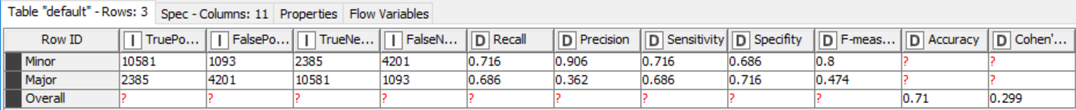

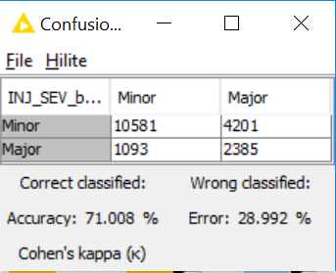

Using the ROC curves that was plotted for the balanced models, we observe all the models have marginally improved. The Decision Tree model remains the least performer and whereas the ANN and Random Forest models have performed decently well.

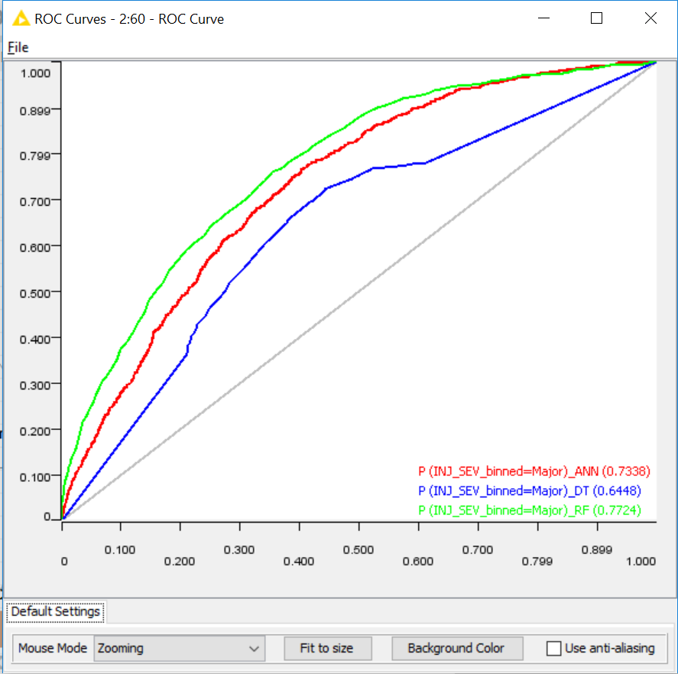

The results from the accuracy statistics of the Random Forest learner node shows the important factors that influence the ‘Major’ injury.

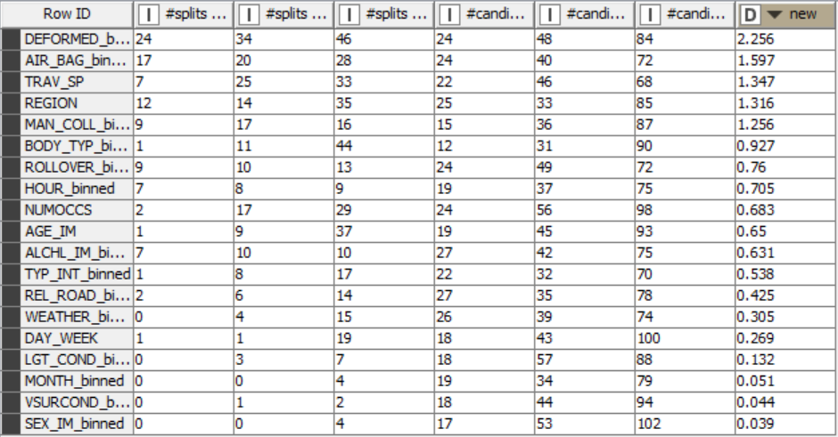

**Deployment and Conclusion**

We have found that the Random Forest model is the best for predicting the results of motor vehicle accidents. The results of this study should be communicated with the NHTSA so that they can take corrective actions as soon as possible. Airbag, traveling speed, Region, body type are some very important predicting factors. Drivers should follow all safety guidelines and install the airbags and keep them turned on all the time while driving. Also, people should be careful to drive in speed limit on respective roads. Not only over speeding causes accidents but also going slow in a high-speed lane was found to be one of the major reasons for the crashes. These insights would also help government to make certain rules and regulations related to speed limit in order to avoid fatal accidents. Region variable would also help police officers to target specific accident-prone region and make required changes. Lawmakers should add some speed limit and region-specific safety rules for heavy vehicles like bus, big trucks because body type is one of the important predictors of accident severity. We also recommend making this research available to the national universities for the purpose of further research and academic application.

In Conclusion, models utilized for this project are only one of the numerous ways this data can be used. Utilizing KNIME and this information, individuals can make models that are custom-made to explicit groups of onlookers, and the outcomes can help make a more secure condition for individuals who work on engine vehicles. The principal result that can be drawn from our project explicitly is the seriousness of injury. This examination helps in concocting safeguard steps that can be taken by individuals and government to help abstain from falling into the patterns. Below is the final workflow of the models.

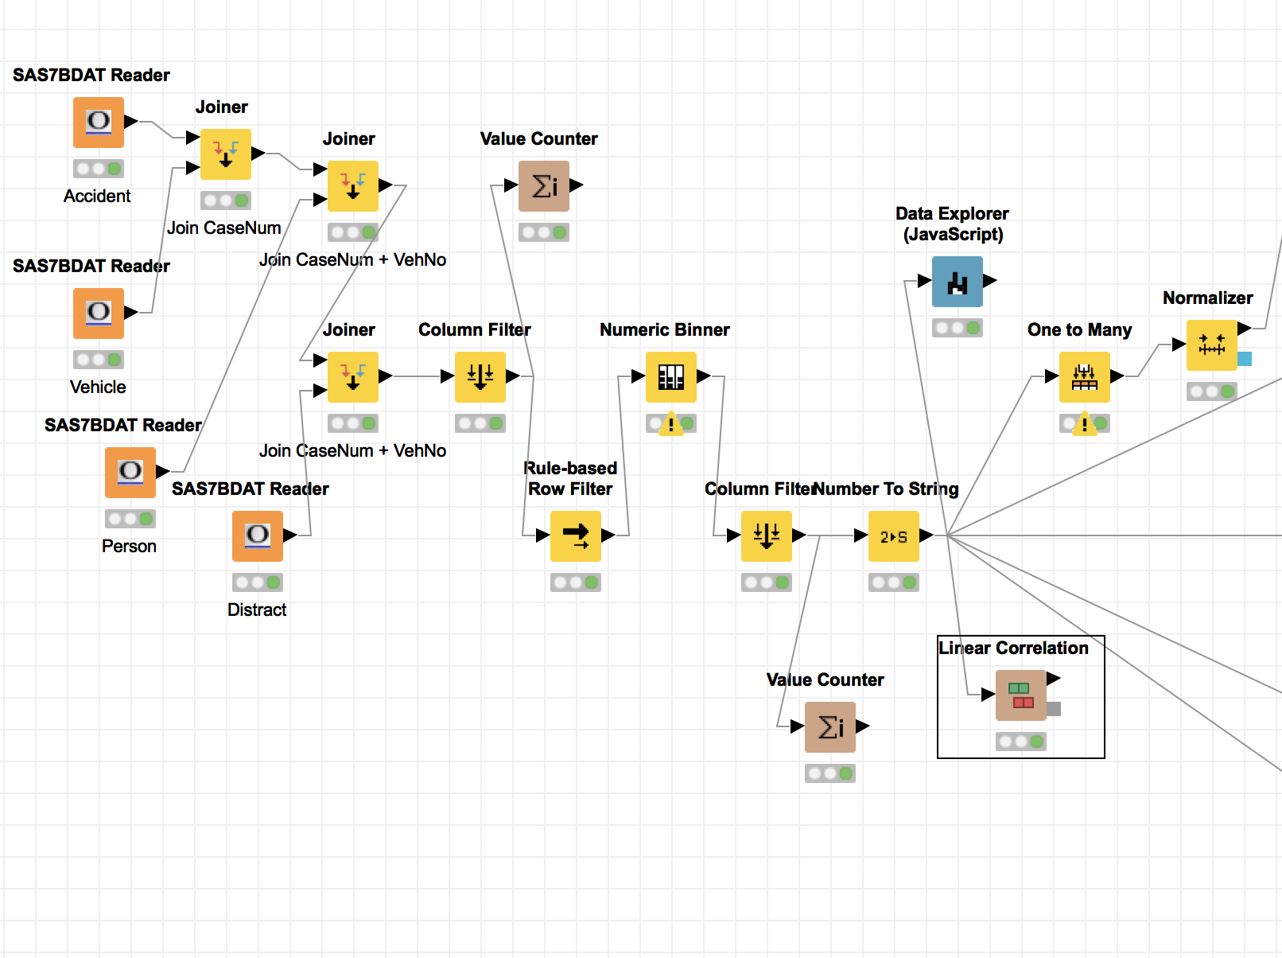

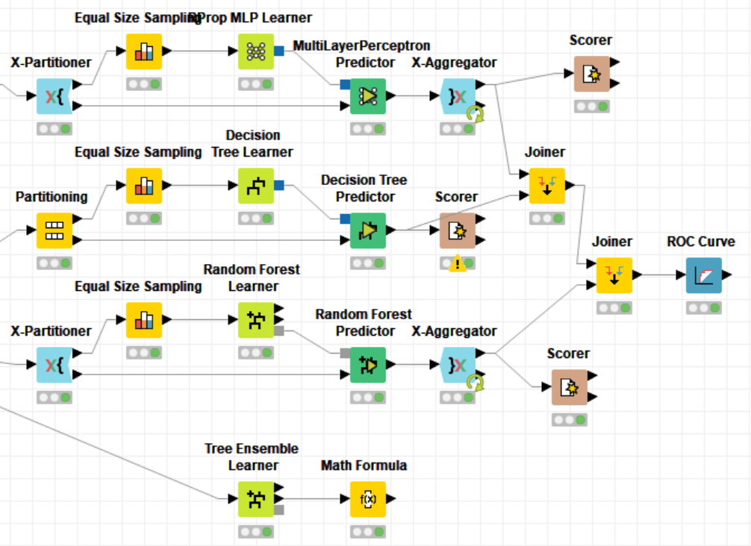

*Final workflow of the models*